Asymmetric DCC correlation: USDJPY and USDCAD
Method 10 / GARCH(1,1) + Cappiello-Engle-Sheppard ADCC / Alpari D1 full available history

Study setup
Logical pair: USDJPY , USDCAD
Broker symbols: USDJPY_i , USDCAD_i
Snapshot: 2026-11-03_majors_alpari_D1
Timeframe: D1
Matched return window: 1999-01-05 to 2026-11-02 (UTC bar dates)
Matched return count n: 7186
Dropped unfinished last bar dated 2026-11-03 UTC after a tick-volume check against the prior complete day.
USDJPY GARCH(1,1): mu=0.000112, omega=0.005024, alpha=0.052093, beta=0.935204
USDCAD GARCH(1,1): mu=-0.000009, omega=0.001260, alpha=0.043668, beta=0.951179
ADCC: a=0.031080, b=0.957040, g=0.000000, a+b+g/2=0.988120
Nested DCC (g=0): a=0.031080, b=0.957040
Negative shock: n = min(z, 0) in broker quote direction (not inverted)
Burn-in ignored in path summaries and chart: first 60 updates
Complete matched rows (Excel): USDJPY-USDCAD_ADCC_D1.xlsx
Complete matched rows (HTML table): USDJPY-USDCAD_ADCC_D1_data.html

Method carried forward
Asymmetric DCC extends Engle DCC with an extra term on joint negative standardised shocks. Each matched daily log return of close, ln(close_t / close_t-1), is first filtered by a constant-mean GARCH(1,1). Then z = residual / sigma and n = min(z, 0). The Cappiello-Engle-Sheppard recursion uses A = (1-a-b) Q_bar - g N_bar with N_bar = mean(n n'). Quotes are not inverted, so a negative shock is a negative log return in the broker quote. Nested symmetric DCC (g = 0) is fit on the same z path for comparison. Constraints: a,b,g >= 0 and a + b + g/2 < 1. Path summaries ignore the first 60 updates. The headline is latest ADCC rho. Pearson r is a side check only. This is not a cause, lead, or trading signal.

Results
Latest ADCC rho: 0.325417
Latest nested DCC rho: 0.325417
Post-burn-in ADCC path (n=7126): mean=0.113741, median=0.130194, min=-0.595891, max=0.573547, std=0.203852
Share of post-burn-in days with |rho| >= 0.4: 7.70%; |rho| >= 0.7: 0.00%
Same-sample Pearson r: 0.027603
ADCC minus r: 0.297814
ADCC minus nested DCC: -0.000000

Conclusion
Over 7186 matched daily log-return rows for USDJPY and USDCAD (broker quote directions unchanged), latest ADCC rho is 0.3254 (positive, weak conditional linear link in this sample) with fitted a=0.0311, b=0.9570, g=0.0000. Nested symmetric DCC latest rho is 0.3254 (ADCC minus DCC = -0.0000). After a 60-day burn-in, path mean is 0.1137 and std is 0.2039. Same-sample Pearson r is 0.0276 (ADCC minus r = 0.2978). This does not establish cause, lead-lag, or a lasting trading rule.

Charts
Daily closes

Daily log returns
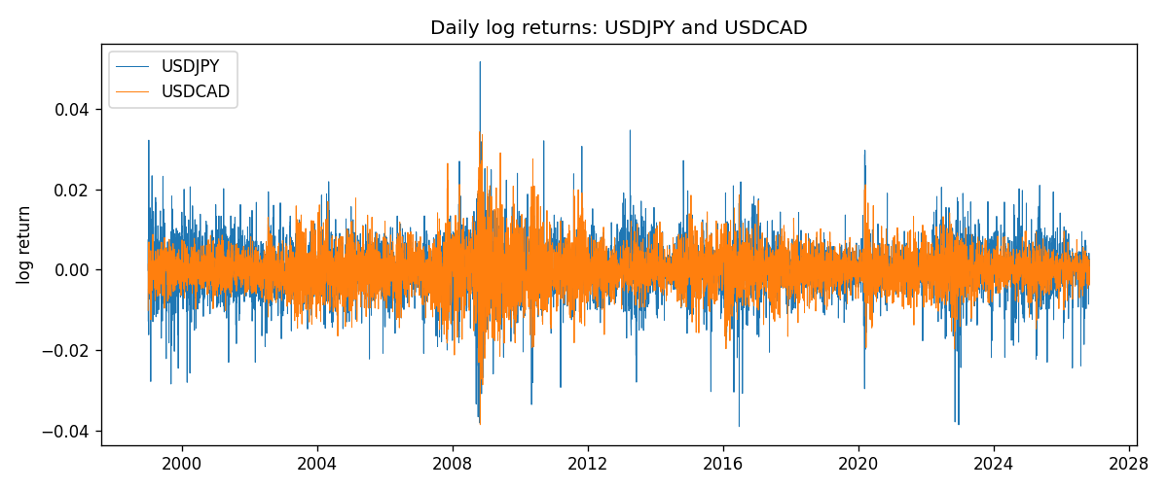
ADCC rho path with nested DCC and Pearson r
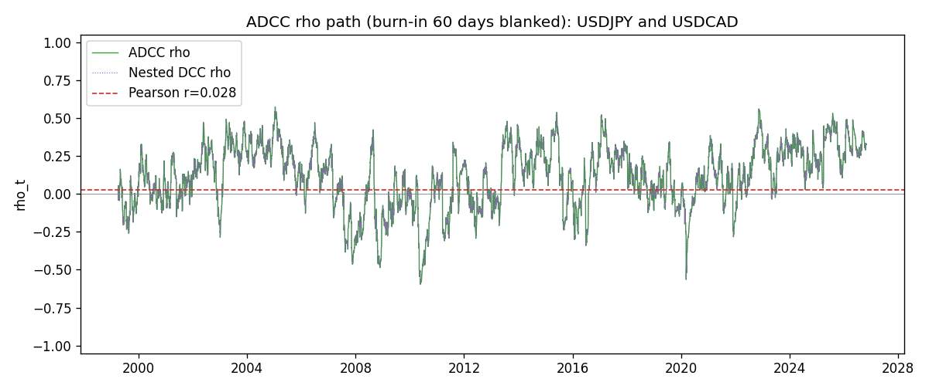

Data report
Every matched row that entered the ADCC recursion is stored in the sibling Excel workbook named USDJPY-USDCAD_ADCC_D1.xlsx. Embedding all rows as a Word table is impractical at this length; the Word file holds the column list, column summaries, and the first and last 15 matched rows.
Columns: time, USDJPY_open, USDCAD_open, USDJPY_high, USDCAD_high, USDJPY_low, USDCAD_low, USDJPY_close, USDCAD_close, USDJPY_tick_volume, USDCAD_tick_volume, USDJPY_spread, USDCAD_spread, USDJPY_real_volume, USDCAD_real_volume, USDJPY_log_return, USDCAD_log_return, USDJPY_sigma, USDCAD_sigma, USDJPY_z, USDCAD_z, USDJPY_n, USDCAD_n, q11, q22, q12, rho_adcc, rho_dcc
Column summaries (matched calculation rows)
column | count | mean | std | min | 25% | 50% | 75% | max
USDJPY_open | 7186 | 113.80748 | 19.222412 | 75.693 | 104.39025 | 110.981 | 120.70625 | 163.824
USDCAD_open | 7186 | 1.266789 | 0.16892251 | 0.9168 | 1.118445 | 1.2985 | 1.37213 | 1.6183
USDJPY_high | 7186 | 114.30511 | 19.284087 | 76.001 | 104.8685 | 111.4395 | 121.2675 | 163.978
USDCAD_high | 7186 | 1.2716872 | 0.16888037 | 0.9336 | 1.122975 | 1.303895 | 1.37655 | 1.619
USDJPY_low | 7186 | 113.28446 | 19.150257 | 75.402 | 103.88 | 110.53 | 120.1715 | 163.628
USDCAD_low | 7186 | 1.2622311 | 0.16895752 | 0.9056 | 1.114125 | 1.293555 | 1.367815 | 1.6102
USDJPY_close | 7186 | 113.82065 | 19.237762 | 75.811 | 104.38275 | 111.018 | 120.69375 | 163.851
USDCAD_close | 7186 | 1.2668036 | 0.16889539 | 0.916 | 1.118165 | 1.29848 | 1.372395 | 1.6137
USDJPY_tick_volume | 7186 | 106329.64 | 179429.89 | 149 | 9948.5 | 53187 | 92874.5 | 1803508
USDCAD_tick_volume | 7186 | 81037.769 | 147318.12 | 37 | 5546.5 | 40944 | 71631 | 1410818
USDJPY_spread | 7186 | 20.270804 | 17.617829 | 0 | 6 | 11 | 30 | 50
USDCAD_spread | 7186 | 23.436682 | 18.263202 | 0 | 9 | 17 | 40 | 60
USDJPY_real_volume | 7186 | 3.4776211e+10 | 1.6092546e+11 | 0 | 0 | 0 | 0 | 3.8834203e+12
USDCAD_real_volume | 7186 | 1.8381818e+10 | 9.6701063e+10 | 0 | 0 | 0 | 0 | 2.5751613e+12
USDJPY_log_return | 7186 | 5.053e-05 | 0.00620694 | -0.03908203 | -0.00319936 | 0.00011986 | 0.0034094 | 0.05184024
USDCAD_log_return | 7186 | -1.555e-05 | 0.00514357 | -0.03859748 | -0.00283709 | 4.741e-05 | 0.00272359 | 0.03436319
USDJPY_sigma | 7186 | 0.00599387 | 0.00174119 | 0.00337358 | 0.0047757 | 0.00569422 | 0.00679946 | 0.01883699
USDCAD_sigma | 7186 | 0.0047945 | 0.00181367 | 0.00251035 | 0.00365456 | 0.00435958 | 0.00534751 | 0.01852647
USDJPY_z | 7186 | -0.00906057 | 1.0002803 | -6.5295109 | -0.56507608 | 0.00168936 | 0.58066029 | 7.1022111
USDCAD_z | 7186 | 0.0015445 | 1.000093 | -4.0694169 | -0.62860696 | 0.01107451 | 0.61213914 | 6.4149327
USDJPY_n | 7186 | -0.37439221 | 0.62365938 | -6.5295109 | -0.56507608 | 0 | 0 | 0
USDCAD_n | 7186 | -0.38694912 | 0.5882562 | -4.0694169 | -0.62860696 | 0 | 0 | 0
q11 | 7186 | 1.0011877 | 0.23167816 | 0.56110545 | 0.84336101 | 0.96788702 | 1.1117454 | 2.312332
q22 | 7186 | 1.0007165 | 0.18524744 | 0.63111159 | 0.88410877 | 0.97313058 | 1.0781394 | 2.544885
q12 | 7186 | 0.10588353 | 0.2282628 | -1.1723993 | -0.01899098 | 0.12010703 | 0.25731286 | 0.95072728
rho_adcc | 7186 | 0.11338296 | 0.20318566 | -0.59589143 | -0.02051264 | 0.12939061 | 0.26923166 | 0.57354691
rho_dcc | 7186 | 0.11338296 | 0.20318569 | -0.5958916 | -0.02051264 | 0.1293906 | 0.26923171 | 0.57354699
First 15 matched rows (selected columns)
time | USDJPY_log_return | USDCAD_log_return | USDJPY_z | USDCAD_z | USDJPY_n | USDCAD_n | q11 | q22 | q12 | rho_adcc | rho_dcc
1999-01-05 | -0.00017868311 | -0.010131666 | -0.025886407 | -2.2372496 | -0.025886407 | -2.2372496 | 1 | 1 | 0.10633807 | 0.10633807 | 0.10633807
1999-01-06 | 0.0075660159 | -0.0003306769 | 0.6850676 | -0.065547824 | 0 | -0.065547824 | 0.96894106 | 1.1244834 | 0.10483307 | 0.10043223 | 0.10043223
1999-01-07 | -0.012851583 | 0.0015202092 | -1.2135246 | 0.31868363 | -1.2135246 | 0 | 0.95378186 | 1.0881893 | 0.10019714 | 0.098350949 | 0.098350948
1999-01-08 | -0.0047719894 | -0.0020495197 | -0.45350293 | -0.43372732 | -0.45350293 | -0.43372732 | 0.97045699 | 1.0564774 | 0.085136498 | 0.084080934 | 0.084080926
1999-01-11 | -0.016195423 | -0.0035137769 | -1.5533699 | -0.75833322 | -1.5533699 | -0.75833322 | 0.94703841 | 1.0288181 | 0.088855637 | 0.090018525 | 0.09001852
1999-01-12 | 0.032310364 | 0.0066194721 | 2.9713686 | 1.4472035 | 0 | 0 | 0.99322805 | 1.0143733 | 0.12291282 | 0.12245422 | 0.12245423
1999-01-13 | 0.0081373171 | 0.0045420214 | 0.62605706 | 0.97031738 | 0 | 0 | 1.2368434 | 1.0477695 | 0.25254423 | 0.22184376 | 0.22184383
1999-01-14 | 0 | 0.0069376546 | -0.0089195059 | 1.4825485 | -0.0089195059 | 0 | 1.2077705 | 1.0438996 | 0.26183841 | 0.233191 | 0.23319107
1999-01-15 | 0.0055343401 | -0.0056905671 | 0.44597412 | -1.1816762 | 0 | -1.1816762 | 1.1677674 | 1.0792457 | 0.25144219 | 0.22397514 | 0.2239752
1999-01-18 | 8.7600193e-05 | 0.00098344542 | -0.0020559355 | 0.20463747 | -0.0020559355 | 0 | 1.1356619 | 1.0881601 | 0.22552463 | 0.20287244 | 0.2028725
1999-01-19 | -0.0056219403 | 0.002748513 | -0.49964372 | 0.58077888 | -0.49964372 | 0 | 1.0987543 | 1.0545945 | 0.21708636 | 0.20166916 | 0.20166922
1999-01-20 | -0.0053879917 | -0.0059646885 | -0.49118518 | -1.2725885 | -0.49118518 | -1.2725885 | 1.0711909 | 1.0316527 | 0.20000486 | 0.19025687 | 0.19025692
1999-01-21 | 0.0084664056 | -0.0042823796 | 0.76478092 | -0.9007472 | 0 | -0.9007472 | 1.0445512 | 1.0495462 | 0.21210322 | 0.20257303 | 0.20257308
1999-01-22 | 0.0060412564 | 0.0025057712 | 0.55114148 | 0.5321686 | 0 | 0 | 1.0297357 | 1.0415544 | 0.18284455 | 0.17655424 | 0.17655428
1999-01-25 | -0.0073594164 | 0.00085579808 | -0.71051606 | 0.18590281 | -0.71051606 | 0 | 1.0068192 | 1.0174913 | 0.18536858 | 0.18314498 | 0.18314502
Last 15 matched rows (selected columns)
time | USDJPY_log_return | USDCAD_log_return | USDJPY_z | USDCAD_z | USDJPY_n | USDCAD_n | q11 | q22 | q12 | rho_adcc | rho_dcc
2026-10-13 | -0.0018932826 | -0.0046395653 | -0.41161815 | -1.603549 | -0.41161815 | -1.603549 | 0.87802954 | 0.82271492 | 0.26723598 | 0.31442399 | 0.31442399
2026-10-14 | 7.5800166e-05 | 0.0015184751 | -0.0075533633 | 0.50936091 | -0.0075533633 | 0 | 0.85745544 | 0.87916887 | 0.27753306 | 0.31964859 | 0.3196486
2026-10-15 | -0.0018524319 | -0.0036101503 | -0.41952615 | -1.2151334 | -0.41952615 | -1.2151334 | 0.83250114 | 0.86134359 | 0.26675401 | 0.31501434 | 0.31501434
2026-10-16 | -0.00037976126 | -0.0034322068 | -0.10677412 | -1.1381435 | -0.10677412 | -1.1381435 | 0.81408721 | 0.88211129 | 0.27240145 | 0.32144914 | 0.32144914
2026-10-19 | 0.0034946841 | -0.0018835331 | 0.7498988 | -0.61658667 | 0 | -0.61658667 | 0.79134856 | 0.89635583 | 0.26573938 | 0.31552355 | 0.31552355
2026-10-20 | -0.0022546642 | -0.0037066008 | -0.52750048 | -1.2277339 | -0.52750048 | -1.2277339 | 0.78671008 | 0.88154448 | 0.24121597 | 0.28965203 | 0.28965202
2026-10-21 | -0.00032883504 | -0.00084691787 | -0.099516825 | -0.27400002 | -0.099516825 | -0.27400002 | 0.77344137 | 0.90240104 | 0.25224487 | 0.30193179 | 0.30193179
2026-10-22 | -0.0085942669 | -0.0026307268 | -2.0047578 | -0.87144649 | -2.0047578 | -0.87144649 | 0.75240233 | 0.87784745 | 0.24351924 | 0.29963924 | 0.29963923
2026-10-23 | 0.00035080446 | 2.85545e-05 | 0.050821396 | 0.012518433 | 0 | 0 | 0.8568706 | 0.87561791 | 0.28861857 | 0.33320333 | 0.33320334
2026-10-26 | 0.0041238746 | 5.7106554e-05 | 0.87209947 | 0.02241175 | 0 | 0 | 0.83201992 | 0.84988645 | 0.27750264 | 0.33000445 | 0.33000445
2026-10-27 | 0.0027651658 | 0.0025379458 | 0.57716193 | 0.87775763 | 0 | 0 | 0.8317945 | 0.82527115 | 0.26745193 | 0.32280435 | 0.32280435
2026-10-28 | -0.00095679538 | -0.0038379274 | -0.23528878 | -1.3196492 | -0.23528878 | -1.3196492 | 0.81829398 | 0.82564338 | 0.2729708 | 0.33209724 | 0.33209725
2026-10-29 | -0.00038043789 | -0.00011436495 | -0.11049641 | -0.035547699 | -0.11049641 | -0.035547699 | 0.79674088 | 0.85617856 | 0.27215754 | 0.32951839 | 0.3295184
2026-10-30 | -0.0010596481 | -0.0010298736 | -0.26817926 | -0.35072025 | -0.26817926 | -0.35072025 | 0.77477257 | 0.83131662 | 0.26185108 | 0.32627516 | 0.32627517
2026-11-02 | 0.0026438521 | 0.00061519094 | 0.58988486 | 0.21761308 | 0 | 0 | 0.7556038 | 0.81130642 | 0.25478853 | 0.32541709 | 0.3254171

